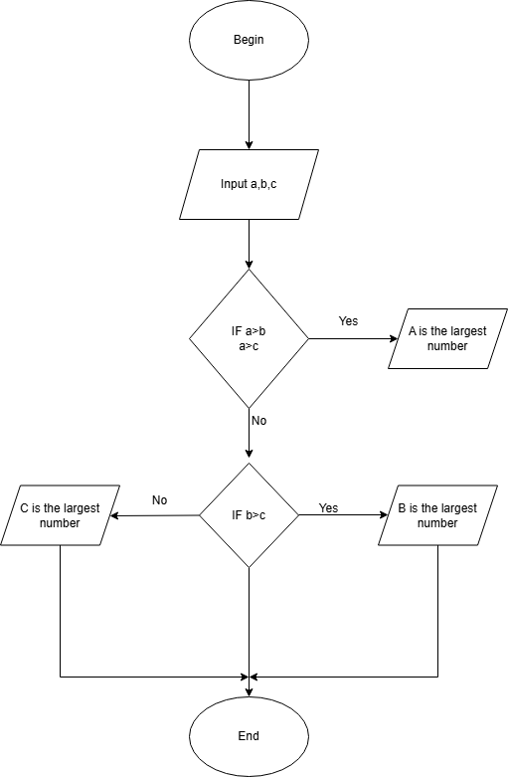

Begin

INPUT A,B,C

IF A > B AND A > C

PRINT A IS MAX

Else

IF B > C

PRINT B IS MAX

ELSE

PRINT C IS MAX

END IF

END IF

END